Property Name | Hoste Barn |  | Date of Next Review: | 11/9/21
Date of Assessment | 11/03/21 |  | Notes: | First guests arrive on 12th April2021
Assessment Carried out by | Dr Paul Everden

What are the Hazards? | Who Might Be Harmed and How? | What are you already doing to control the Risk? | What further action do you need to take to control the risk? | Risk Factor / Urgency
 |  |  |  | High | Medium | Low
Person to person contact during COVID 19 pandemic (Host and guest)  Directly or indirectly. | The host  The guest  The guests of guests  The cleaners  Any other service provider  If appropriate messures are not taken with regards to cleaning then they may  Become infected with COVID19 and further spread the infection | Our usual professional cleaning company is working to Covid recommended guidelines. (see attached). They are specialists in self catering accommodation and are working strictly to Covid recommended guidance from PASC.  Host is observing all infection control risks. Masks and alcohol gel are being used at all times.  Regular handwashing.  All bought items for inclusion in barn are cleaned and quarantined.  Social distancing is remaining at 2m. There will be minimal contact between the two parties. Protective clothing for any welcome staff and ensure guests and welcome staff understand social distancing guidelines.  No loud voices or shouting. Distinct garden area for sole use. There are no communal play areas. Outside seating soley for guests and will be cleaned appropriately.  Tennis court will have all contact points cleaned at change over and will be for their sole use during their stay.  Any service provider for emergency maintainence who need access to the barn will use PPE and attempt to enter at change over times.  Provide a pre-arrival/ departure pack for guests explaining procedures.  Use self-check in with lock boxes with Host to video call or phone the guests after guest arrival to ensure customer satisfaction and to answer all queries  Ensure guests are not present during interim cleans  We have a welcome folder which encompasses  When bin day is  How the boiler works  How to switch the heating on  How the cooker works  This will minimise any visit to the property  We have an illness during stay reporting procedure and useful contact numbers in the property  Guests will not be able to get in early when cleaners are still on site or drop off luggage and belongings as this may put the guests and the team at risk.  Any mid let cleans or laundry changes will only be done without guests present. Cleaners will wear gloves and will be asked to sanitise any touchpoints they have used while inside the property.  Guests will be sent instructions to complete before departure. See attachment.  Removal of some items (ornaments, decorative bed cushions etc). Rotation of soft furnishings (cushions) between changeovers to minimise risk. Items such as games removed, but available on request. | WE WOULD NOT CONSIDER OPENING UNTIL RISK HAS BEEN IDENTIFIED AND CONTROL TO BEST ABILITY SO THERE ARE NO OUTSTANDING ACTIONS.  WE WILL REVIEW REGULARLY AND RESPOND TO NEW GUIDANCE IMMEDIATELY.

Cleaner / housekeeper not fit for work and infected with COVID 19 | Could spread COVID 19 through cleaning within the property | We are using a cleaning company who will be assessing their staf for fitness prior to work. They will be waring PPE and following their cleaning company guidelines.
Cleaning regimes not effective / fit for purpose | Contaminated accommodation / spread of COVID 19 | Cleaning company is self regulating and has strict Covid protocols in place to meet recommended standards based on PASC guidelines to meet all recommended standards.
Incorrect / ineffective cleaning materials used / Cleaning regimes not recorded | Not cleaning or sanitising the property correctly | Cleaning company is self regulating and has strict Covid protocols in place to meet recommended standards based on PASC guidelines to meet all recommended standards.

Dealing with a guest who is unwell or infectious outbreak in your property | The spread of an infection within the guest group and any contacts they may have had either outside the property or within. | We will have all contact details of guests and guest’s of guests before they arrive to allow track and trace.  We have a document in the property explaining symptoms and what to do if a guest is unwell including relevant phone numbers and further actions.  Video call/ call the guests to clearly understand the situation and if the guests need to extend their stay and for how long.  We have a separate terms and conditions with the cost and requirements if a guest has to extend their stay through illness for self-quarantine. We will encorouge the guest to return home if unwell.  Cleaning company will deliver clean linen and linen bag for the guests to place used linen in.
Incorrectly laundered bedding | Virus remains a hazard | Cleaning company will appropriately aunder all bedding according to guidance.
Changeover clean | Contaminated accommodation / spread of COVID 19 | Cleaning company will ensure all regulations are adhered to as above.  All changeover cleans can only be completed once the guests have left the property
Legionella | Infection of Legionella from standing water if the property has been lying empty | Water sytem has been flushed.  Shower head has been removed and soaked and disinfected.  All taps have been run for 2 minutes.  Flush the whole water system for two minutes or more. First flush your toilet, then let the kitchen taps and the hand basin taps run for two minutes or more to let both hot and cold water pass through.

Notes on completion | 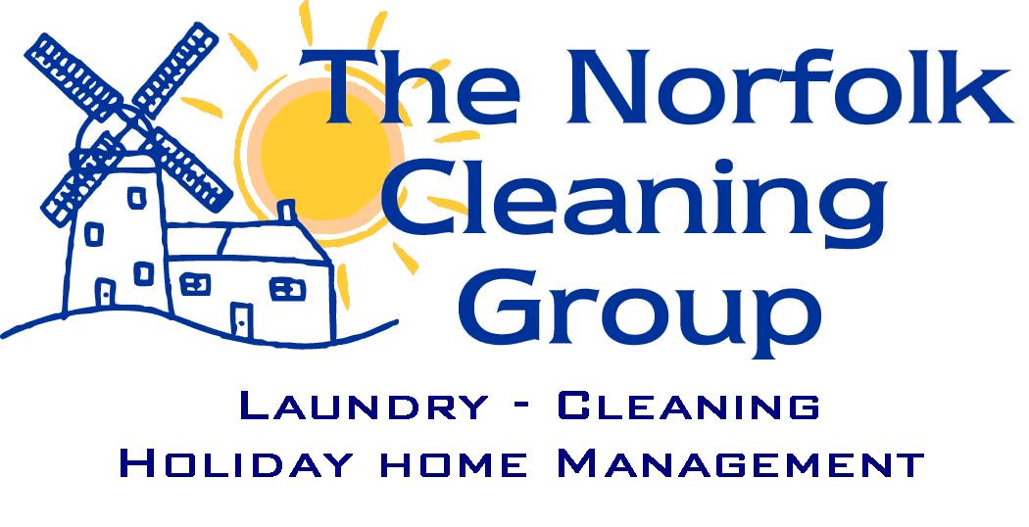  The Norfolk Cleaning COVID Protocol  Introduction  As you can imagine we have all been inundated with information regarding the COVID-19 virus. This guide will try and set out our plan for the ‘new’ normal. As normal we will do our utmost to provide the best level of service we can throughout the season, but we will need to make some adjustments to our working practices.  We have fulfilled our requirements regarding being COVID Secure which has been published on our website and our risk assessments are in place for our operation.  Our aim during this time is to ensure the safety of our customers, your guests and our team.  Before the 1st Booking  As many of the holiday homes have been empty for some time, we are going to introduce a new ‘refresh’ cleaning programme to help support our customers before your new guests arrive. The refresh clean will include a full vacuum/mop of floors, dusting throughout, a check of beds and re-make if required and a sanitise of all touch points.  To keep it simple we have provided a price for this clean based on the number of bedrooms:  - 1-2 bed £30+VAT  - 3 bed £40+VAT  - 4-5 bed £50+VAT  - More than 6 beds £60+VAT.  If you would like us to book this in before the arrival of your first guests, then please let us know.  Please do let us know as soon as possible if you require our services as we are going to be working in a different way and may only have limited capacity.  If you would like a deeper clean then please contact the office for pricing – this can include carpets, upholstery and ovens as well as deep cleans of all rooms.  Cleaning Guidelines and Standards  We intend to continue to complete the normal changeover clean as agreed with our clients.  All our cleaning products are commercially sourced and provide the best cleaning agents including sanitising, viricidal and disinfectant. They also meet the requirements for cleaning in a non-healthcare environment as published on gov.uk.  Our team have been instructed to wear gloves throughout the clean, wash hands at the start and end of the clean and all teams have been issued with sanitiser.  In addition to the normal changeover clean we will sanitise touchpoints using a product called Viraklean or Selgiene. This will include:  - Door handles and window handles  - Stair Bannisters  - Taps and flushes  - Light switches  - Keys and key safe  - Remote controls  - Accessible plugs and sockets  - Blind cords  - Welcome folders  If any other cleaning is required or you have any special requests, then please get in touch with the office as this will need to be agreed and additional time added to the clean. We would suggest that you liaise with your guests or agent to ensure they understand the level of clean which will take place.  Guests Cleaning Pack  We are able to provide a pack for your property which will include:  - Hand sanitiser 500ml (£8+VAT each)  - Viraklean Sanitiser for touch points (hospital approved) 750ml (£4+VAT each)  - 100 Anti bac wipes (£4.50+VAT each)  This can be added to your property for a cost of £15.50+VAT for all 3 or they can be purchased singularly as above. Just let the office know by email if you would like them added.  Please note that a new pack will be supplied at every clean.  Protecting you and our team.  Our priority during this time is to keep you, your guests and our team protected and secure while managing the risk.  This will mean:  - Staff will always wear gloves and be provided with face masks and aprons.  - Teams are instructed to wash hands at the start and the end of every clean as well as using sanitiser when they finally leave the property.  - All cleaning cloths and mop heads are laundered at the end of every day. New cloths and mop heads are used for each property and dirty are segregated from clean.  - Team members are asked to confirm before they leave every day if they have symptoms, or anyone else in the family have symptoms.  - Due to social distancing teams will only travel in teams of 2 and in most cases only work in teams of 2. (Although for the larger areas with space they will be able to work in multiple teams)  - Teams will not go into a property where guests are still in. If they arrive and the guests have not left, then they will be asked to contact the office. This may mean moving the clean to the end of the day, a delay for new guests arriving and additional charges for travel time.  - All linen and towels will be washed at 60 degrees as per guidance.  - Guests will not be able to get in early when cleaners are still on site or drop off luggage and belongings as this may put the guests and the team at risk.  - Any mid let cleans or laundry changes will only be done without guests present. Cleaners will wear gloves and will be asked to sanitise any touchpoints they have used while inside the property.  - Our checkers will also wear gloves at all times and will be given sanitiser to ensure they wipe any touchpoints they use e.g. key safes.  Arrival and Departure Times  To enable us to complete the clean and work in smaller teams and ensure that the property is left to the high standard for the incoming guests we are going to change the times that properties will be ready.  Therefore, from July 4th bookings departure time will need to be 9am and arrivals 5pm. If you have specific issues, then please contact the office for further advice.  Last Minute Bookings  As you know we will always do our very best to accommodate last minute bookings. We still intend to do our best but would ask that we now have a minimum of 48 hours for a last-minute booking which will start on Friday or Saturday. This means bookings on Wednesday for Friday and Thursday for Saturday.  Other arrival days will not be affected, but this will help with our planning and ensure the property is ready in the right way for the new guests.  Can we ask for your help?  These are unprecedented times and although we believe that the summer will be busy, it will be a different ‘normal’.  Therefore, could we ask you to help us continue to provide the best service for your guests:  - Where possible and you have contact with guests, we would ask that before they leave, they are asked to confirm if anyone has or has had any COVID symptoms.  - Guests to strip all beds and towels and leave in the bathroom.  - Guests to ensure if the dishwasher is full, please switch it on so it is clean when the team arrive.  - Empty all bins from all rooms and dispose of the waste as per your property guidance.  This will help us with some time to ensure we can concentrate on the sanitsation of touch point while ensuring the team do not have to handle as much dirty laundry, rubbish and crockery.  We would also ask that owners who are local and may be around during the clean stays within the social distance guidelines while the clean takes place.  What if the guests have symptoms while staying in the property?  If the guests report symptoms during their stay, then they will need to follow the guidelines as stated on gov.uk.  Once the guests leave, we will not be able to go into the property for 72 hours after departure. We will then need to go into the property and do a COVID clean. If this does happen then please contact the office for advice and pricing.  We have left an information document in the property for guests to report any symptoms to use before departure.

